PERFORMANCE TESTING REPORTS

1. Page speed and optimization

Made by: ENG : Habiba ragab Abdelmoneam

Page speed and optimization

**Tools**: Google Speed insights

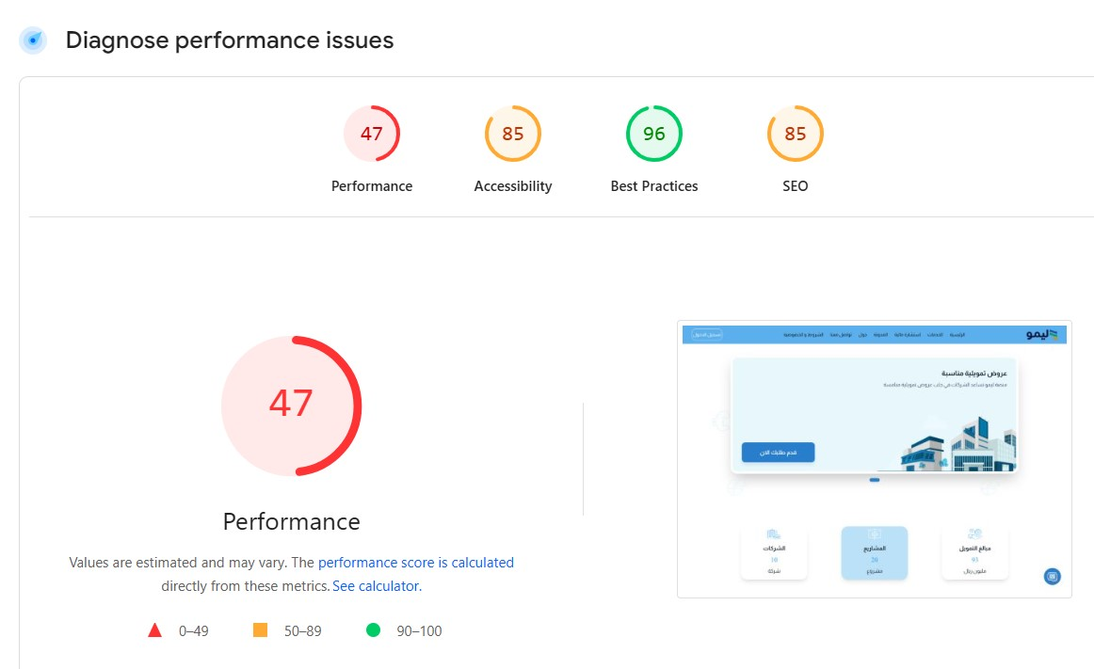

**Diagnostics**

1-Avoid large layout shift: (4 layout shift found)

These are the largest layout shifts observed on the page. Each table item represents a single layout shift, and shows

The element that shifted the most. Below each item are possible root causes that led to the layout shift. Some of layout shifts may not be included in the CLS metric value due to windowing

Enable text compression :

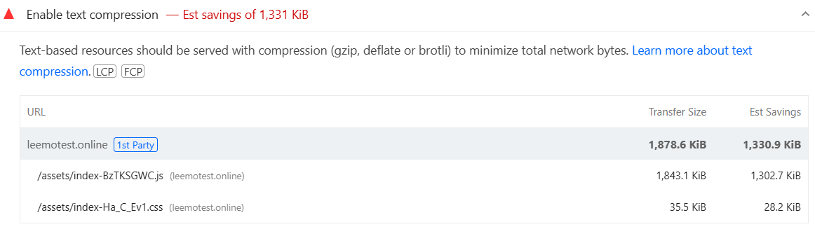

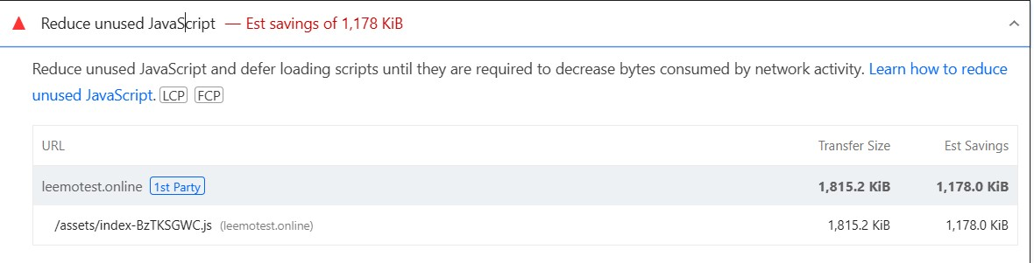 Reduce unused JavaScript: (Est Saving of 1,178KiB):

Largest contentful paint element: (2,590ms)

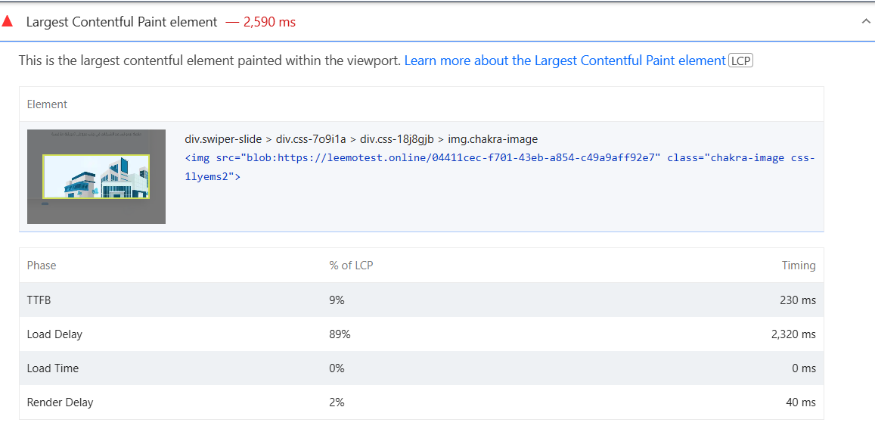

Avoid serving legacy JavaScript to modern browsers:

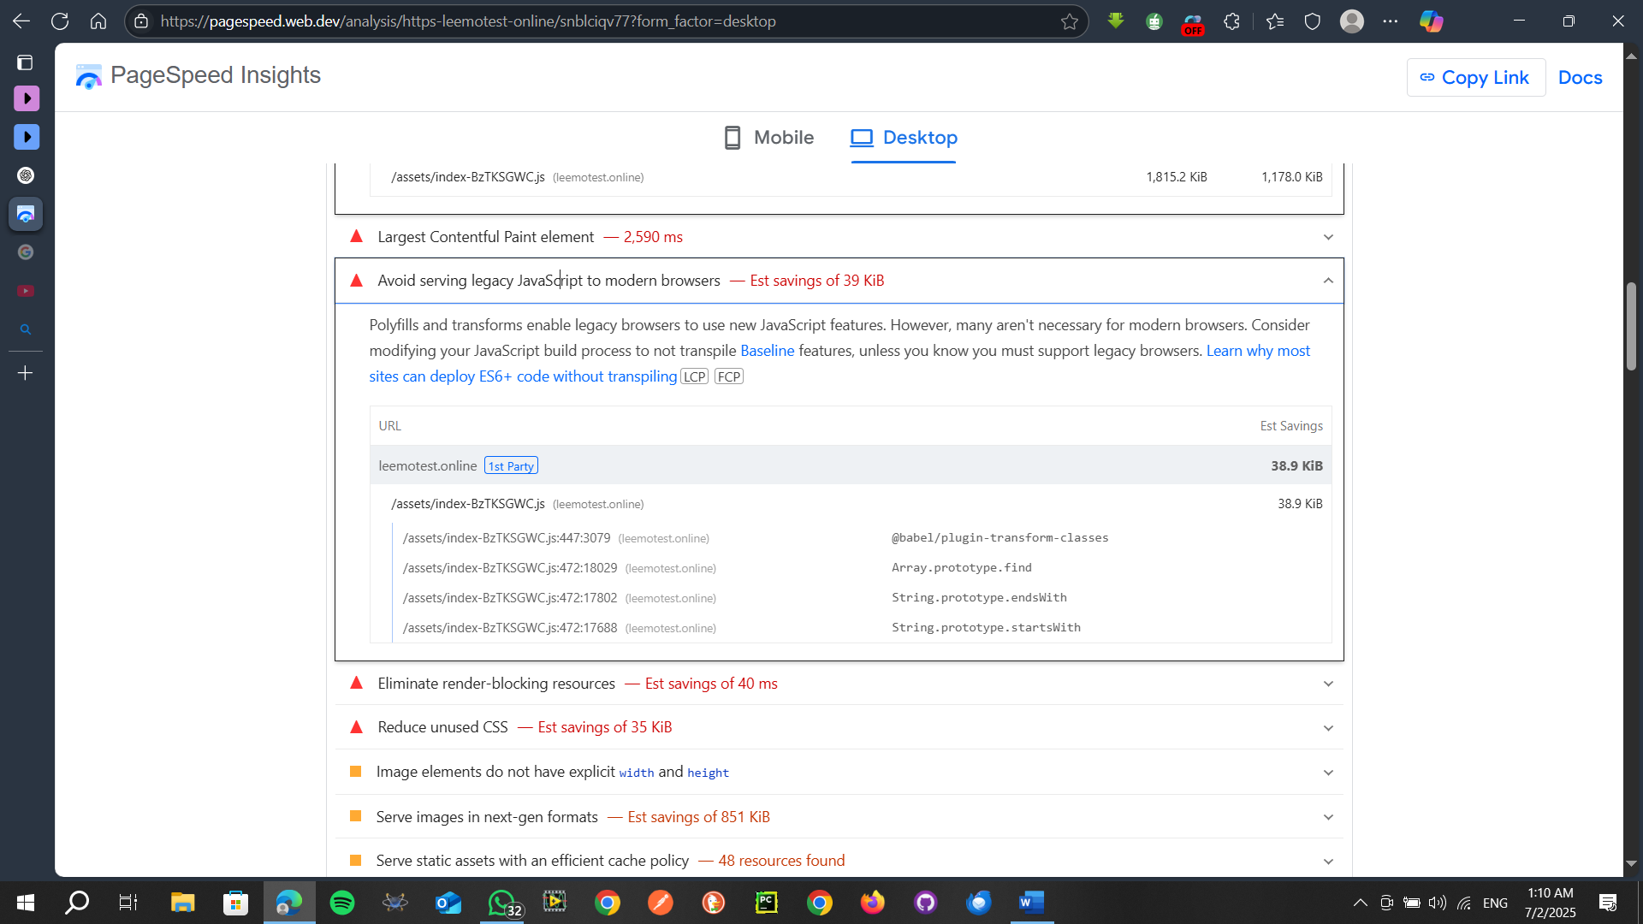

Eliminate render-blocking resources :

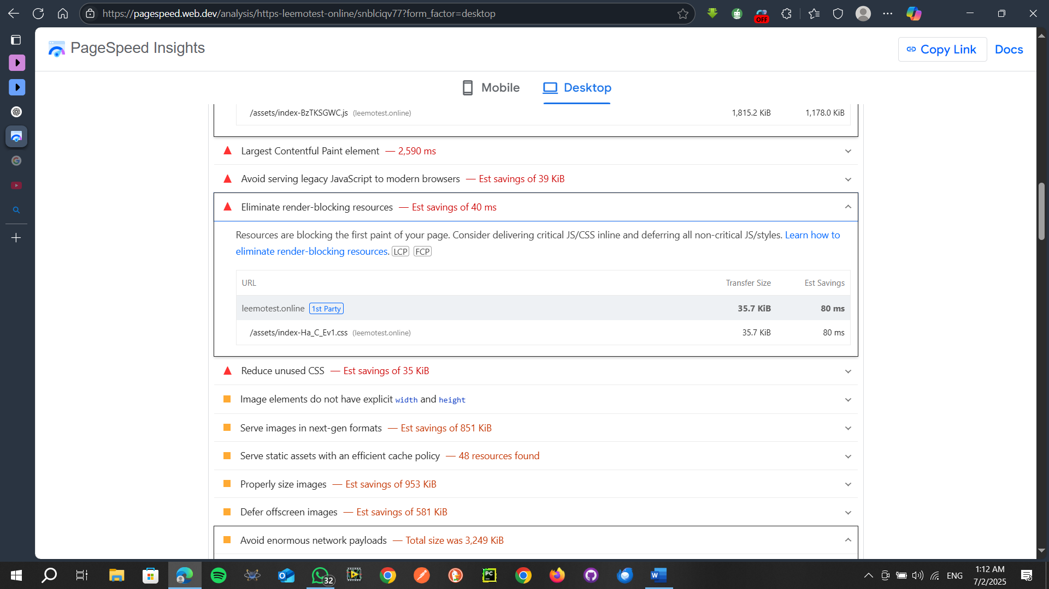

Reduce unused CSS:

Image elements do not have explicit width and height:

|  |  |
| --- | --- |
| section.css-q8vawr > div.css-18bhl3t > div.css-pprm9f > img.chakra-image  <img src="blob:https://leemotest.online/0c5a14a8-90e2-4f5e-9df2-de468f72dbfc" class="chakra-image css-1mx93q4"> | blob:https://leemotest.online/0c5a14a8-90e2-4f5e-9df2-de468f72dbfc |
| section.css-q8vawr > div.css-18bhl3t > div.css-pprm9f > img.chakra-image  <img src="blob:https://leemotest.online/1f6899fa-4550-4cce-b0de-3f50e2f65ac0" class="chakra-image css-1mx93q4"> | blob:https://leemotest.online/1f6899fa-4550-4cce-b0de-3f50e2f65ac0 |
| About Lemo  <img alt="About Lemo" src="/assets/images/aboutLemo.png" class="chakra-image css-1175mch"> | […images/aboutLemo.png](https://leemotest.online/assets/images/aboutLemo.png)  (leemotest.online) |
| Full box image  <img alt="Full box image" src="/assets/images/calculation/calc-image.png" class="chakra-image css-lgui1a"> | […calculation/calc-image.png](https://leemotest.online/assets/images/calculation/calc-image.png)  (leemotest.online) |
| section.css-q8vawr > div.css-18bhl3t > div.css-pprm9f > img.chakra-image  <img src="blob:https://leemotest.online/20e89fc4-330f-44e6-abd3-f7642d34bd67" class="chakra-image css-1mx93q4"> | blob:https://leemotest.online/20e89fc4-330f-44e6-abd3-f7642d34bd67 |
| section.css-q8vawr > div.css-18bhl3t > div.css-pprm9f > img.chakra-image  <img src="blob:https://leemotest.online/4dadd629-adce-4c5f-95d5-f70951ee036e" class="chakra-image css-1mx93q4"> | blob:https://leemotest.online/4dadd629-adce-4c5f-95d5-f70951ee036e |
| حاسبة التورق  <img alt="حاسبة التورق" src="/assets/images/calculation/calc-3.png" class="chakra-image css-z76hn5"> | […calculation/calc-3.png](https://leemotest.online/assets/images/calculation/calc-3.png)  (leemotest.online) |
| حاسبة التمويل  <img alt="حاسبة التمويل" src="/assets/images/calculation/calc-1.png" class="chakra-image css-z76hn5"> | […calculation/calc-1.png](https://leemotest.online/assets/images/calculation/calc-1.png)  (leemotest.online) |
| حاسبة الزكاة  <img alt="حاسبة الزكاة" src="/assets/images/calculation/calc-2.png" class="chakra-image css-z76hn5"> | […calculation/calc-2.png](https://leemotest.online/assets/images/calculation/calc-2.png)  (leemotest.online) |
| حاسبة المرابحة  <img alt="حاسبة المرابحة" src="/assets/images/calculation/calc-4.png" class="chakra-image css-z76hn5"> | […calculation/calc-4.png](https://leemotest.online/assets/images/calculation/calc-4.png)  (leemotest.online) |
| حاسبة الإجارة  <img alt="حاسبة الإجارة" src="/assets/images/calculation/calc-5.png" class="chakra-image css-z76hn5"> | […calculation/calc-5.png](https://leemotest.online/assets/images/calculation/calc-5.png)  (leemotest.online) |
| حاسبة الاستصناع  <img alt="حاسبة الاستصناع" src="/assets/images/calculation/calc-6.png" class="chakra-image css-z76hn5"> | […calculation/calc-6.png](https://leemotest.online/assets/images/calculation/calc-6.png)  (leemotest.online) |
| حاسبة السلم  <img alt="حاسبة السلم" src="/assets/images/calculation/calc-7.png" class="chakra-image css-z76hn5"> | […calculation/calc-7.png](https://leemotest.online/assets/images/calculation/calc-7.png)  (leemotest.online) |
| حاسبة المضاربة  <img alt="حاسبة المضاربة" src="/assets/images/calculation/calc-8.png" class="chakra-image css-z76hn5"> | […calculation/calc-8.png](https://leemotest.online/assets/images/calculation/calc-8.png)  (leemotest.online) |
| حاسبة المشاركة  <img alt="حاسبة المشاركة" src="/assets/images/calculation/calc-9.png" class="chakra-image css-z76hn5"> | […calculation/calc-9.png](https://leemotest.online/assets/images/calculation/calc-9.png)  (leemotest.online) |
| section.css-q8vawr > div.css-18bhl3t > div.css-pprm9f > img.chakra-image  <img src="blob:https://leemotest.online/0f43adbb-2aea-41e6-843b-43eba29313a3" class="chakra-image css-1mx93q4"> | blob:https://leemotest.online/0f43adbb-2aea-41e6-843b-43eba29313a3 |
| About Lemo  <img alt="About Lemo" src="/assets/images/Lemo-About.png" class="chakra-image css-1s2joss"> | […images/Lemo-About.png](https://leemotest.online/assets/images/Lemo-About.png)  (leemotest.online) |
| section.css-q8vawr > div.css-18bhl3t > div.css-pprm9f > img.chakra-image  <img src="blob:https://leemotest.online/eefd38ce-1a15-4456-8ade-0bf51d2ee423" class="chakra-image css-1mx93q4"> | blob:https://leemotest.online/eefd38ce-1a15-4456-8ade-0bf51d2ee423 |
| section.css-q8vawr > div.css-18bhl3t > div.css-pprm9f > img.chakra-image  <img src="blob:https://leemotest.online/1dab9e24-6923-4747-98ef-90de427621b1" class="chakra-image css-1mx93q4"> | blob:https://leemotest.online/1dab9e24-6923-4747-98ef-90de427621b1 |
| section.css-q8vawr > div.css-18bhl3t > div.css-pprm9f > img.chakra-image  <img src="blob:https://leemotest.online/3dd14008-f2a0-4fb6-a756-1666fe25ead8" class="chakra-image css-1mx93q4"> | blob:https://leemotest.online/3dd14008-f2a0-4fb6-a756-1666fe25ead8 |
| section.css-q8vawr > div.css-18bhl3t > div.css-pprm9f > img.chakra-image  <img src="blob:https://leemotest.online/6bb03ff3-1ee4-47d5-bfeb-57b09eb0329e" class="chakra-image css-1mx93q4"> | blob:https://leemotest.online/6bb03ff3-1ee4-47d5-bfeb-57b09eb0329e |
| section.css-q8vawr > div.css-18bhl3t > div.css-pprm9f > img.chakra-image  <img src="blob:https://leemotest.online/dfd4cafa-1a2a-4740-87df-f42b6e74ef5a" class="chakra-image css-1mx93q4"> | blob:https://leemotest.online/dfd4cafa-1a2a-4740-87df-f42b6e74ef5a |
| section.css-q8vawr > div.css-18bhl3t > div.css-pprm9f > img.chakra-image  <img src="blob:https://leemotest.online/fdfdac75-7915-4aba-8457-f186ea170bb1" class="chakra-image css-1mx93q4"> | blob:https://leemotest.online/fdfdac75-7915-4aba-8457-f186ea170bb1 |
| section.css-q8vawr > div.css-18bhl3t > div.css-pprm9f > img.chakra-image  <img src="blob:https://leemotest.online/d31b0484-fcf8-4391-8e70-b50586bfac30" class="chakra-image css-1mx93q4"> | blob:https://leemotest.online/d31b0484-fcf8-4391-8e70-b50586bfac30 |
| section.css-q8vawr > div.css-18bhl3t > div.css-pprm9f > img.chakra-image  <img src="blob:https://leemotest.online/b397e265-f70a-4f52-a530-fd0c3a2a42a9" class="chakra-image css-1mx93q4"> | blob:https://leemotest.online/b397e265-f70a-4f52-a530-fd0c3a2a42a9 |
| section.css-q8vawr > div.css-18bhl3t > div.css-pprm9f > img.chakra-image  <img src="blob:https://leemotest.online/13779c64-3336-4dbd-b8e0-b1a5786247ed" class="chakra-image css-1mx93q4"> | blob:https://leemotest.online/13779c64-3336-4dbd-b8e0-b1a5786247ed |
| section.css-q8vawr > div.css-18bhl3t > div.css-pprm9f > img.chakra-image  <img src="blob:https://leemotest.online/60975db6-bf60-4615-8ce0-282f712c3f75" class="chakra-image css-1mx93q4"> | blob:https://leemotest.online/60975db6-bf60-4615-8ce0-282f712c3f75 |
| section.css-q8vawr > div.css-18bhl3t > div.css-pprm9f > img.chakra-image  <img src="blob:https://leemotest.online/de7d3535-c97c-450b-b5fd-ede6f839bfc8" class="chakra-image css-1mx93q4"> | blob:https://leemotest.online/de7d3535-c97c-450b-b5fd-ede6f839bfc8 |
| section.css-q8vawr > div.css-18bhl3t > div.css-pprm9f > img.chakra-image  <img src="blob:https://leemotest.online/9ccad032-914f-4849-a801-25a5c56dee03" class="chakra-image css-1mx93q4"> | blob:https://leemotest.online/9ccad032-914f-4849-a801-25a5c56dee03 |
| section.css-q8vawr > div.css-18bhl3t > div.css-pprm9f > img.chakra-image  <img src="blob:https://leemotest.online/8b40d6de-88fd-4599-9195-1fdc4cff1262" class="chakra-image css-1mx93q4"> | blob:https://leemotest.online/8b40d6de-88fd-4599-9195-1fdc4cff1262 |
| section.css-q8vawr > div.css-18bhl3t > div.css-pprm9f > img.chakra-image  <img src="blob:https://leemotest.online/c5e80c73-db86-43f1-9c50-6fa635829c21" class="chakra-image css-1mx93q4"> | blob:https://leemotest.online/c5e80c73-db86-43f1-9c50-6fa635829c21 |
| section.css-q8vawr > div.css-18bhl3t > div.css-pprm9f > img.chakra-image  <img src="blob:https://leemotest.online/41399df3-a5f0-4377-a03c-9ab728b467a1" class="chakra-image css-1mx93q4"> | blob:https://leemotest.online/41399df3-a5f0-4377-a03c-9ab728b467a1 |
| section.css-q8vawr > div.css-18bhl3t > div.css-pprm9f > img.chakra-image  <img src="blob:https://leemotest.online/f5d07af6-5c2d-492c-9ef5-7dbd4310f76b" class="chakra-image css-1mx93q4"> | blob:https://leemotest.online/f5d07af6-5c2d-492c-9ef5-7dbd4310f76b |
| section.css-q8vawr > div.css-18bhl3t > div.css-pprm9f > img.chakra-image  <img src="blob:https://leemotest.online/54bee338-627d-4019-83c0-b97031e8c100" class="chakra-image css-1mx93q4"> | blob:https://leemotest.online/54bee338-627d-4019-83c0-b97031e8c100 |
| section.css-q8vawr > div.css-18bhl3t > div.css-pprm9f > img.chakra-image  <img src="blob:https://leemotest.online/9a5e521a-28bf-402b-9e4e-efb2c4d57e5f" class="chakra-image css-1mx93q4"> | blob:https://leemotest.online/9a5e521a-28bf-402b-9e4e-efb2c4d57e5f |
| section.css-q8vawr > div.css-18bhl3t > div.css-pprm9f > img.chakra-image  <img src="blob:https://leemotest.online/39ee89e0-5973-4a22-92ed-37b4227cc866" class="chakra-image css-1mx93q4"> | blob:https://leemotest.online/39ee89e0-5973-4a22-92ed-37b4227cc866 |
| section.css-q8vawr > div.css-18bhl3t > div.css-pprm9f > img.chakra-image  <img src="blob:https://leemotest.online/5e41076e-9a26-40c3-9fb2-3975ce0d9e90" class="chakra-image css-1mx93q4"> | blob:https://leemotest.online/5e41076e-9a26-40c3-9fb2-3975ce0d9e90 |
| section.css-q8vawr > div.css-18bhl3t > div.css-pprm9f > img.chakra-image  <img src="blob:https://leemotest.online/6f847839-ecd9-4cae-8cb5-d62612d62af9" class="chakra-image css-1mx93q4"> | blob:https://leemotest.online/6f847839-ecd9-4cae-8cb5-d62612d62af9 |
| section.css-q8vawr > div.css-18bhl3t > div.css-pprm9f > img.chakra-image  <img src="blob:https://leemotest.online/80ea7f28-e741-4516-bc3e-1fd45a85b0c2" class="chakra-image css-1mx93q4"> | blob:https://leemotest.online/80ea7f28-e741-4516-bc3e-1fd45a85b0c2 |
| section.css-q8vawr > div.css-18bhl3t > div.css-pprm9f > img.chakra-image  <img src="blob:https://leemotest.online/19f39fb4-0bd8-4073-adec-5990984b2a37" class="chakra-image css-1mx93q4"> | blob:https://leemotest.online/19f39fb4-0bd8-4073-adec-5990984b2a37 |
| section.css-q8vawr > div.css-18bhl3t > div.css-pprm9f > img.chakra-image  <img src="blob:https://leemotest.online/d9da51bb-d87d-4af2-b741-47ae4eb55317" class="chakra-image css-1mx93q4"> | blob:https://leemotest.online/d9da51bb-d87d-4af2-b741-47ae4eb55317 |
| Product صكوك المضاربة  <img alt="Product صكوك المضاربة" src="/assets/images/productHome/product-9.png" class="chakra-image css-5sx8q7"> | […productHome/product-9.png](https://leemotest.online/assets/images/productHome/product-9.png)  (leemotest.online) |
| section.css-q8vawr > div.css-18bhl3t > div.css-pprm9f > img.chakra-image  <img src="blob:https://leemotest.online/73cb5474-3637-4482-a19b-f7c0af373d2e" class="chakra-image css-1mx93q4"> | blob:https://leemotest.online/73cb5474-3637-4482-a19b-f7c0af373d2e |
| Product صكوك الإجارة  <img alt="Product صكوك الإجارة" src="/assets/images/productHome/product-3.png" class="chakra-image css-5sx8q7"> | […productHome/product-3.png](https://leemotest.online/assets/images/productHome/product-3.png)  (leemotest.online) |
| Product رأس المال العامل  <img alt="Product رأس المال العامل" src="/assets/images/productHome/product-7.png" class="chakra-image css-5sx8q7"> | […productHome/product-7.png](https://leemotest.online/assets/images/productHome/product-7.png)  (leemotest.online) |
| Product نقاط البيع  <img alt="Product نقاط البيع" src="/assets/images/productHome/product-1.png" class="chakra-image css-5sx8q7"> | […productHome/product-1.png](https://leemotest.online/assets/images/productHome/product-1.png)  (leemotest.online) |
| Product صكوك المشاركة  <img alt="Product صكوك المشاركة" src="/assets/images/productHome/product-2.png" class="chakra-image css-5sx8q7"> | […productHome/product-2.png](https://leemotest.online/assets/images/productHome/product-2.png)  (leemotest.online) |
| Product تمويل الآجل  <img alt="Product تمويل الآجل" src="/assets/images/productHome/product-5.png" class="chakra-image css-5sx8q7"> | […productHome/product-5.png](https://leemotest.online/assets/images/productHome/product-5.png)  (leemotest.online) |
| Product تمويل المخزون  <img alt="Product تمويل المخزون" src="/assets/images/productHome/product-4.png" class="chakra-image css-5sx8q7"> | […productHome/product-4.png](https://leemotest.online/assets/images/productHome/product-4.png)  (leemotest.online) |
| Product تمويل الفواتير  <img alt="Product تمويل الفواتير" src="/assets/images/productHome/product-8.png" class="chakra-image css-5sx8q7"> | […productHome/product-8.png](https://leemotest.online/assets/images/productHome/product-8.png)  (leemotest.online) |
| Product صكوك المرابحة  <img alt="Product صكوك المرابحة" src="/assets/images/productHome/product-6.png" class="chakra-image css-5sx8q7"> | […productHome/product-6.png](https://leemotest.online/assets/images/productHome/product-6.png)  (leemotest.online) |
| div.chakra-stack > div.css-q9f2vv > a > img.chakra-image  <img src="/assets/images/about/youtube.png" class="chakra-image css-9crlzn"> | […about/youtube.png](https://leemotest.online/assets/images/about/youtube.png)  (leemotest.online) |
| div.chakra-stack > div.css-q9f2vv > a > img.chakra-image  <img src="/assets/images/about/instagram.png" class="chakra-image css-9crlzn"> | […about/instagram.png](https://leemotest.online/assets/images/about/instagram.png)  (leemotest.online) |
| div.chakra-stack > div.css-q9f2vv > a > img.chakra-image  <img src="/assets/images/about/linkedin.png" class="chakra-image css-9crlzn"> | […about/linkedin.png](https://leemotest.online/assets/images/about/linkedin.png)  (leemotest.online) |
| div.chakra-stack > div.css-q9f2vv > a > img.chakra-image  <img src="/assets/images/about/x.png" class="chakra-image css-9crlzn"> | […about/x.png](https://leemotest.online/assets/images/about/x.png)  (leemotest.online) |
| div.chakra-stack > div.css-q9f2vv > a > img.chakra-image  <img src="/assets/images/about/facebook.png" class="chakra-image css-9crlzn"> | […about/facebook.png](https://leemotest.online/assets/images/about/facebook.png)  (leemotest.online) |

Serve images in next -gen formats

Image formats like WebP and AVIF often provide better compression than PNG or JPEG, which means faster downloads and less data consumption. [Learn more about modern image formats](https://developer.chrome.com/docs/lighthouse/performance/uses-webp-images/?utm_source=lighthouse&utm_medium=lr).LCPFCP

|  | URL | Resource Size | Est Savings |
| --- | --- | --- | --- |
| leemotest.online   1st party |  | **1,031.5 KiB** | **850.6 KiB** |
| section.css-q8vawr > div.css-18bhl3t > div.css-pprm9f > img.chakra-image  <img src="blob:https://leemotest.online/1f6899fa-4550-4cce-b0de-3f50e2f65ac0" class="chakra-image css-1mx93q4"> | blob:https://leemotest.online/1f6899fa-4550-4cce-b0de-3f50e2f65ac0 | 377.2 KiB | 349.9 KiB |
| section.css-q8vawr > div.css-18bhl3t > div.css-pprm9f > img.chakra-image  <img src="blob:https://leemotest.online/0c5a14a8-90e2-4f5e-9df2-de468f72dbfc" class="chakra-image css-1mx93q4"> | blob:https://leemotest.online/0c5a14a8-90e2-4f5e-9df2-de468f72dbfc | 164.6 KiB | 124.3 KiB |
| حاسبة التورق  <img alt="حاسبة التورق" src="/assets/images/calculation/calc-3.png" class="chakra-image css-z76hn5"> | […calculation/calc-3.png](https://leemotest.online/assets/images/calculation/calc-3.png)  (leemotest.online) | 88.1 KiB | 72.9 KiB |
| حاسبة السلم  <img alt="حاسبة السلم" src="/assets/images/calculation/calc-7.png" class="chakra-image css-z76hn5"> | […calculation/calc-7.png](https://leemotest.online/assets/images/calculation/calc-7.png)  (leemotest.online) | 67.2 KiB | 56.5 KiB |
| حاسبة التمويل  <img alt="حاسبة التمويل" src="/assets/images/calculation/calc-1.png" class="chakra-image css-z76hn5"> | […calculation/calc-1.png](https://leemotest.online/assets/images/calculation/calc-1.png)  (leemotest.online) | 47.9 KiB | 37.7 KiB |
| حاسبة الزكاة  <img alt="حاسبة الزكاة" src="/assets/images/calculation/calc-2.png" class="chakra-image css-z76hn5"> | […calculation/calc-2.png](https://leemotest.online/assets/images/calculation/calc-2.png)  (leemotest.online) | 44.7 KiB | 35.7 KiB |
| حاسبة الإجارة  <img alt="حاسبة الإجارة" src="/assets/images/calculation/calc-5.png" class="chakra-image css-z76hn5"> | […calculation/calc-5.png](https://leemotest.online/assets/images/calculation/calc-5.png)  (leemotest.online) | 39.8 KiB | 31.3 KiB |
| حاسبة المشاركة  <img alt="حاسبة المشاركة" src="/assets/images/calculation/calc-9.png" class="chakra-image css-z76hn5"> | […calculation/calc-9.png](https://leemotest.online/assets/images/calculation/calc-9.png)  (leemotest.online) | 35.5 KiB | 27.0 KiB |
| Full box image  <img alt="Full box image" src="/assets/images/calculation/calc-image.png" class="chakra-image css-lgui1a"> | […calculation/calc-image.png](https://leemotest.online/assets/images/calculation/calc-image.png)  (leemotest.online) | 38.8 KiB | 26.9 KiB |
| حاسبة الاستصناع  <img alt="حاسبة الاستصناع" src="/assets/images/calculation/calc-6.png" class="chakra-image css-z76hn5"> | […calculation/calc-6.png](https://leemotest.online/assets/images/calculation/calc-6.png)  (leemotest.online) | 34.5 KiB | 26.7 KiB |
| حاسبة المرابحة  <img alt="حاسبة المرابحة" src="/assets/images/calculation/calc-4.png" class="chakra-image css-z76hn5"> | […calculation/calc-4.png](https://leemotest.online/assets/images/calculation/calc-4.png)  (leemotest.online) | 25.4 KiB | 19.4 KiB |
| حاسبة المضاربة  <img alt="حاسبة المضاربة" src="/assets/images/calculation/calc-8.png" class="chakra-image css-z76hn5"> | […calculation/calc-8.png](https://leemotest.online/assets/images/calculation/calc-8.png)  (leemotest.online) | 23.8 KiB | 17.9 KiB |
| About Lemo  <img alt="About Lemo" src="/assets/images/aboutLemo.png" class="chakra-image css-1175mch"> | […images/aboutLemo.png](https://leemotest.online/assets/images/aboutLemo.png)  (leemotest.online) | 22.8 KiB | 13.9 KiB |
| div.swiper-slide > div.css-7o9i1a > div.css-18j8gjb > img.chakra-image  <img src="blob:https://leemotest.online/04411cec-f701-43eb-a854-c49a9aff92e7" class="chakra-image css-1lyems2"> |  |  |  |

Serve static assets with an efficient cache policy

A long cache lifetime can speed up repeat visits to your page. [Learn more about efficient cache policies](https://developer.chrome.com/docs/lighthouse/performance/uses-long-cache-ttl/?utm_source=lighthouse&utm_medium=lr).

| URL | Cache TTL | Transfer Size |
| --- | --- | --- |
| leemotest.online   1st party |  | **2,578 KiB** |
| [/assets/index-BzTKSGWC.js](https://leemotest.online/assets/index-BzTKSGWC.js)  (leemotest.online) | None | 1,843 KiB |
| […calculation/calc-3.png](https://leemotest.online/assets/images/calculation/calc-3.png)  (leemotest.online) | None | 88 KiB |
| […calculation/calc-7.png](https://leemotest.online/assets/images/calculation/calc-7.png)  (leemotest.online) | None | 67 KiB |
| […calculation/calc-1.png](https://leemotest.online/assets/images/calculation/calc-1.png)  (leemotest.online) | None | 48 KiB |
| […calculation/calc-2.png](https://leemotest.online/assets/images/calculation/calc-2.png)  (leemotest.online) | None | 45 KiB |
| […calculation/calc-5.png](https://leemotest.online/assets/images/calculation/calc-5.png)  (leemotest.online) | None | 40 KiB |
| […calculation/calc-image.png](https://leemotest.online/assets/images/calculation/calc-image.png)  (leemotest.online) | None | 39 KiB |
| […calculation/calc-9.png](https://leemotest.online/assets/images/calculation/calc-9.png)  (leemotest.online) | None | 36 KiB |
| [/assets/index-Ha_C_Ev1.css](https://leemotest.online/assets/index-Ha_C_Ev1.css)  (leemotest.online) | None | 36 KiB |
| […calculation/calc-6.png](https://leemotest.online/assets/images/calculation/calc-6.png)  (leemotest.online) | None | 35 KiB |
| [/assets/almarai-a….woff2](https://leemotest.online/assets/almarai-arabic-800-normal-q55zvtRO.woff2)  (leemotest.online) | None | 33 KiB |
| [/assets/almarai-a….woff2](https://leemotest.online/assets/almarai-arabic-700-normal-RufW5IrK.woff2)  (leemotest.online) | None | 32 KiB |
| [/assets/almarai-a….woff2](https://leemotest.online/assets/almarai-arabic-400-normal-BFOw1b4Z.woff2)  (leemotest.online) | None | 31 KiB |
| […calculation/calc-4.png](https://leemotest.online/assets/images/calculation/calc-4.png)  (leemotest.online) | None | 26 KiB |
| […calculation/calc-8.png](https://leemotest.online/assets/images/calculation/calc-8.png)  (leemotest.online) | None | 24 KiB |
| […images/aboutLemo.png](https://leemotest.online/assets/images/aboutLemo.png)  (leemotest.online) | None | 23 KiB |
| […productHome/product-1.png](https://leemotest.online/assets/images/productHome/product-1.png)  (leemotest.online) | None | 8 KiB |
| […images/Lemo-About.png](https://leemotest.online/assets/images/Lemo-About.png)  (leemotest.online) | None | 8 KiB |
| […HowTo/howTo-5.png](https://leemotest.online/assets/images/HowTo/howTo-5.png)  (leemotest.online) | None | 8 KiB |
| […images/icon9.png](https://leemotest.online/assets/images/icon9.png)  (leemotest.online) | None | 7 KiB |
| […images/icon7.png](https://leemotest.online/assets/images/icon7.png)  (leemotest.online) | None | 7 KiB |
| […HowTo/howTo-1.png](https://leemotest.online/assets/images/HowTo/howTo-1.png)  (leemotest.online) | None | 6 KiB |
| […HowTo/howTo-4.png](https://leemotest.online/assets/images/HowTo/howTo-4.png)  (leemotest.online) | None | 6 KiB |
| […HowTo/howTo-2.png](https://leemotest.online/assets/images/HowTo/howTo-2.png)  (leemotest.online) | None | 6 KiB |
| […images/icon3.png](https://leemotest.online/assets/images/icon3.png)  (leemotest.online) | None | 5 KiB |
| […productHome/product-2.png](https://leemotest.online/assets/images/productHome/product-2.png)  (leemotest.online) | None | 5 KiB |
| […images/lemo-logo.png](https://leemotest.online/assets/images/lemo-logo.png)  (leemotest.online) | None | 5 KiB |
| […productHome/product-5.png](https://leemotest.online/assets/images/productHome/product-5.png)  (leemotest.online) | None | 5 KiB |
| […images/icon2.png](https://leemotest.online/assets/images/icon2.png)  (leemotest.online) | None | 5 KiB |
| […productHome/product-9.png](https://leemotest.online/assets/images/productHome/product-9.png)  (leemotest.online) | None | 5 KiB |
| […productHome/product-7.png](https://leemotest.online/assets/images/productHome/product-7.png)  (leemotest.online) | None | 5 KiB |
| […images/icon5.png](https://leemotest.online/assets/images/icon5.png)  (leemotest.online) | None | 5 KiB |
| […HowTo/howTo-3.png](https://leemotest.online/assets/images/HowTo/howTo-3.png)  (leemotest.online) | None | 4 KiB |
| […productHome/product-3.png](https://leemotest.online/assets/images/productHome/product-3.png)  (leemotest.online) | None | 4 KiB |
| […productHome/product-4.png](https://leemotest.online/assets/images/productHome/product-4.png)  (leemotest.online) | None | 4 KiB |
| […productHome/product-6.png](https://leemotest.online/assets/images/productHome/product-6.png)  (leemotest.online) | None | 4 KiB |
| […bot/icons8.png](https://leemotest.online/assets/images/bot/icons8.png)  (leemotest.online) | None | 3 KiB |
| […productHome/product-8.png](https://leemotest.online/assets/images/productHome/product-8.png)  (leemotest.online) | None | 3 KiB |
| […about/graph.png](https://leemotest.online/assets/images/about/graph.png)  (leemotest.online) | None | 3 KiB |
| […images/icon8.png](https://leemotest.online/assets/images/icon8.png)  (leemotest.online) | None | 2 KiB |
| […about/instagram.png](https://leemotest.online/assets/images/about/instagram.png)  (leemotest.online) | None | 1 KiB |
| […about/youtube.png](https://leemotest.online/assets/images/about/youtube.png)  (leemotest.online) | None | 1 KiB |
| […HowTo/howTo-.png](https://leemotest.online/assets/images/HowTo/howTo-.png)  (leemotest.online) | None | 1 KiB |
| […about/linkedin.png](https://leemotest.online/assets/images/about/linkedin.png)  (leemotest.online) | None | 1 KiB |
| […about/facebook.png](https://leemotest.online/assets/images/about/facebook.png)  (leemotest.online) | None | 1 KiB |
| […about/x.png](https://leemotest.online/assets/images/about/x.png)  (leemotest.online) | None | 1 KiB |
| […about/whatsapp.png](https://leemotest.online/assets/images/about/whatsapp.png)  (leemotest.online) | None | 1 KiB |
| […about/msg.png](https://leemotest.online/assets/images/about/msg.png)  (leemotest.online) |  |  |

Properly size images :

Defer offscreen images:

Avoid enormous network payloads :

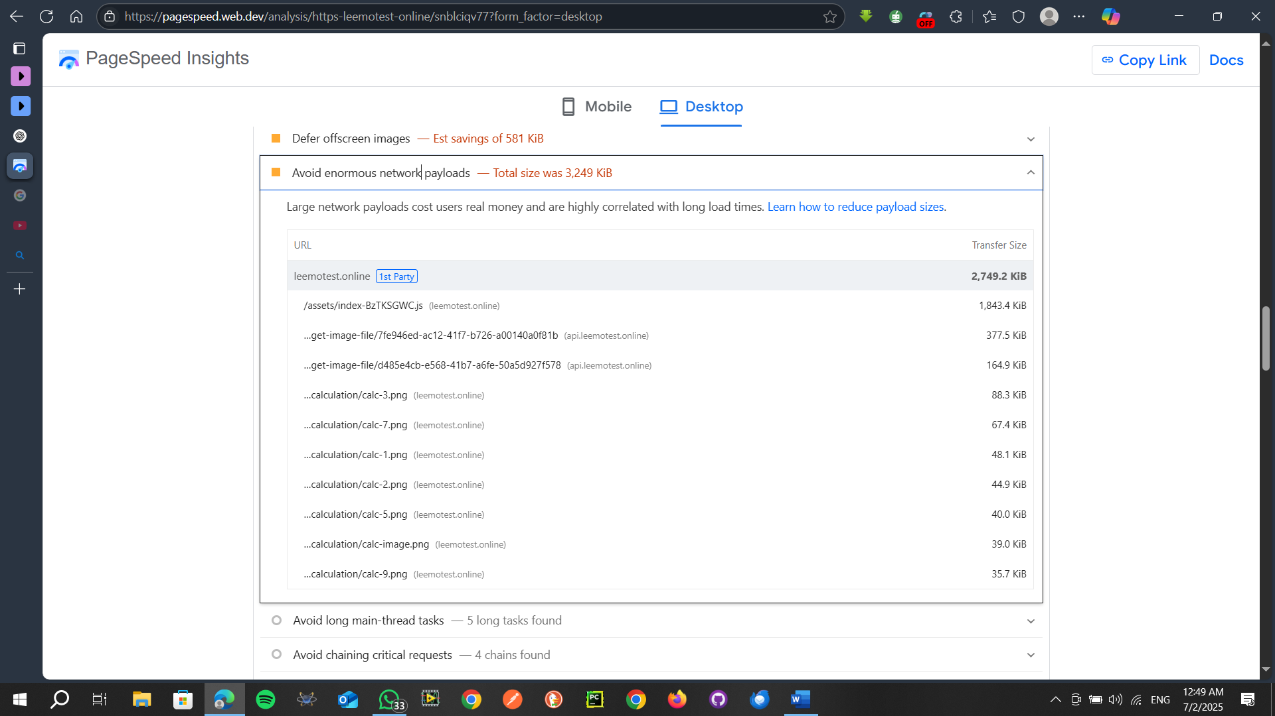

Avoid long main-thread tasks:

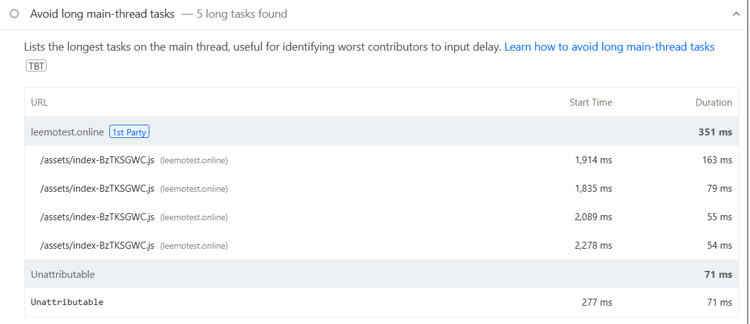

Avoid chaining critical requests (4chain found)

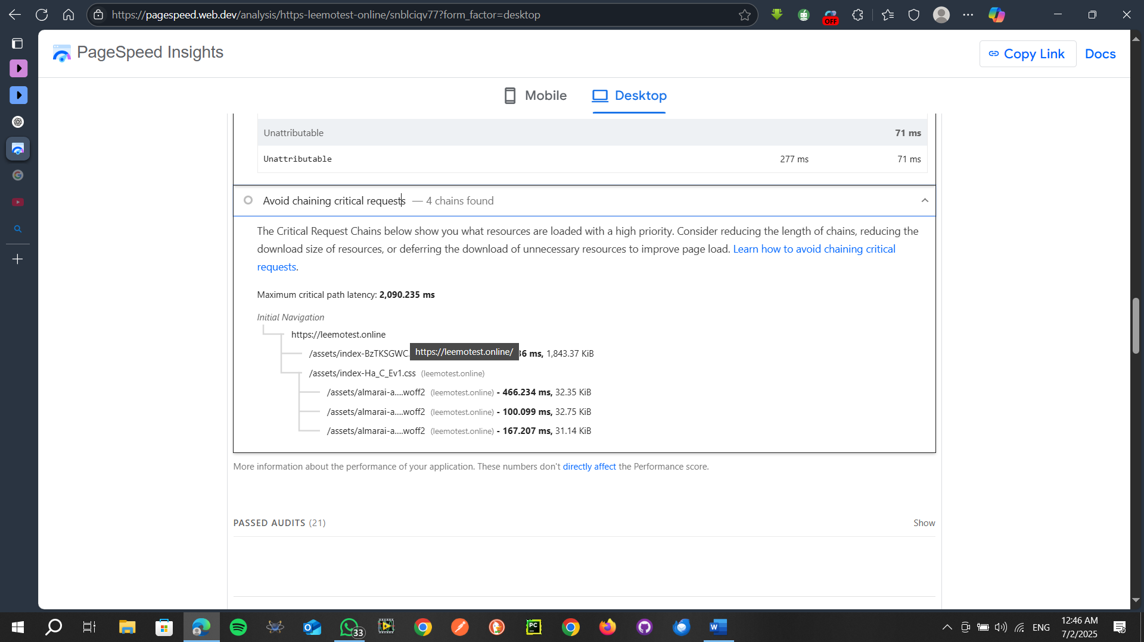

<https://pagespeed.web.dev/analysis/https-leemotest-online/snblciqv77?form_factor=desktop>

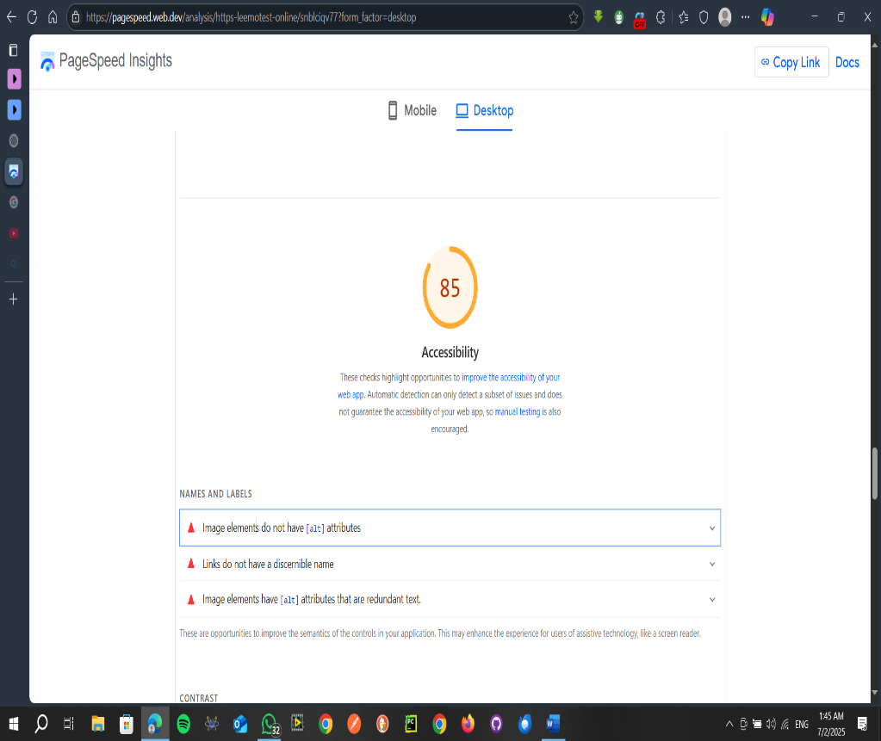 ( to check all results for the website )

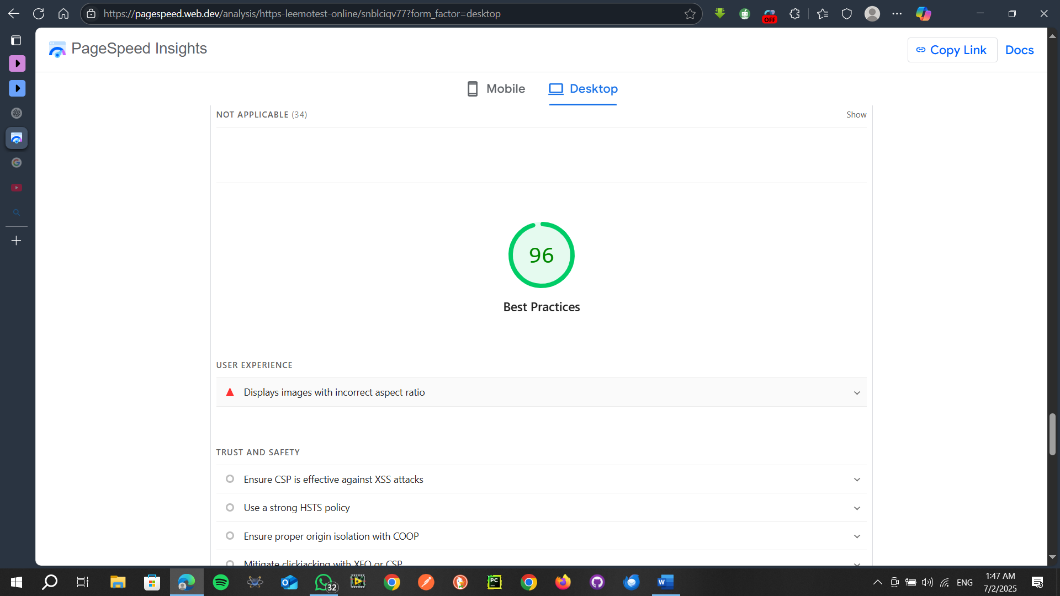

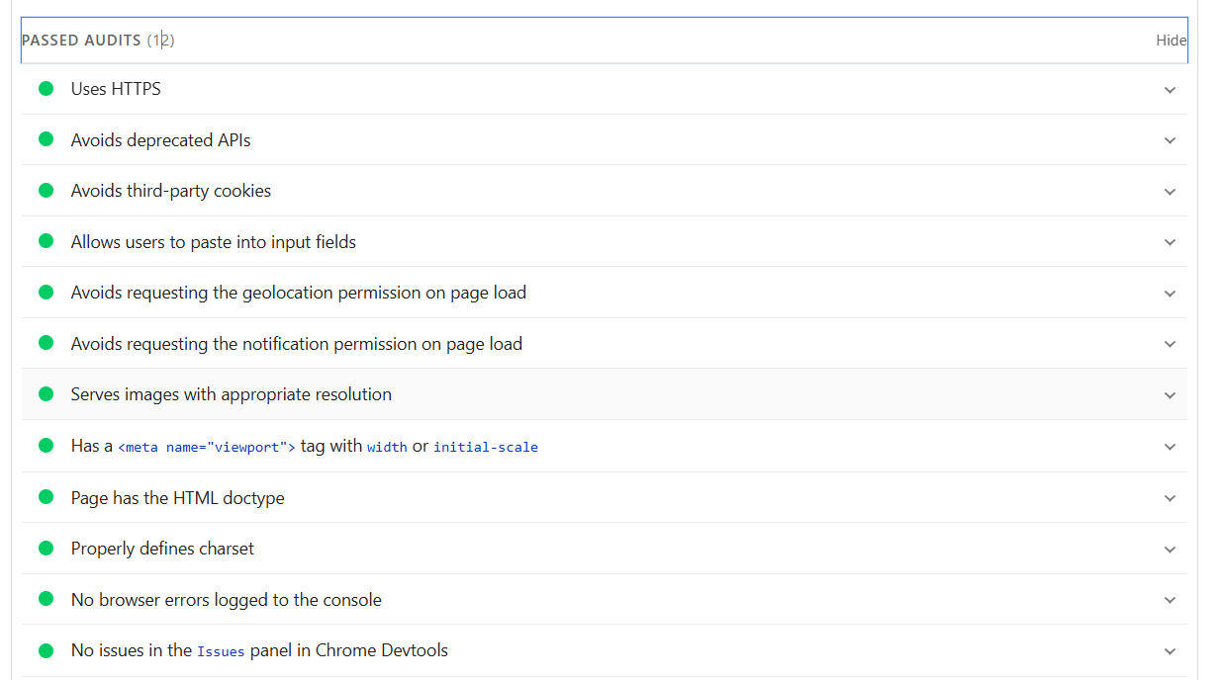

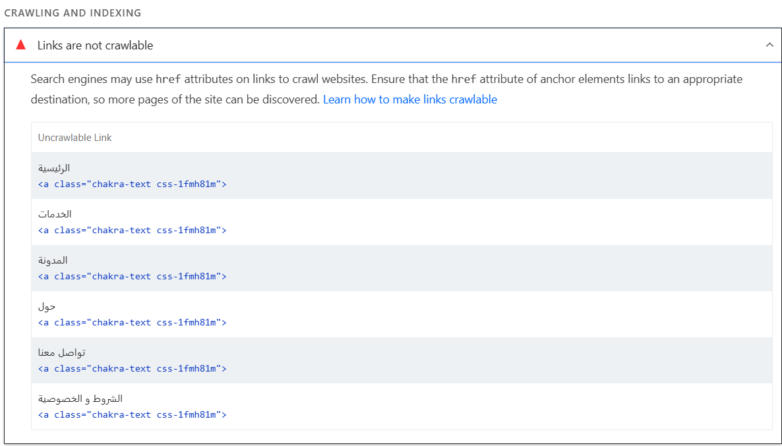

For mobile

<https://pagespeed.web.dev/analysis/https-leemotest-online/b94vqvpjof?form_factor=mobile>

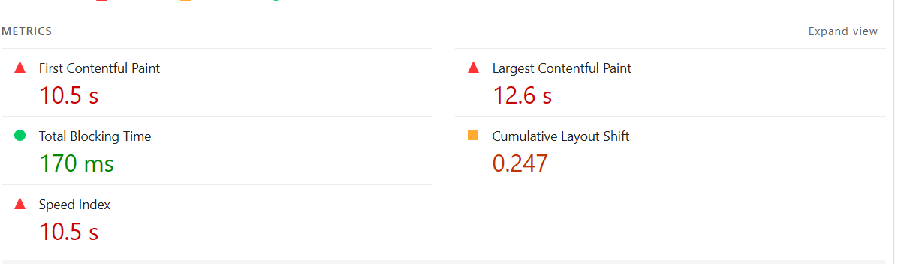

الموقع يُظهر أداءً جيدًا على الأجهزة المكتبية، لكنه يحتاج تحسينات ملحوظة على الموبايل لتحسين سرعة التفاعل وتجربة المستخدم. التوصيات المذكورة أعلاه ستساهم بشكل كبير في رفع تقييم الأداء وتقليل زمن التحميل.